**EXERCISE 1: RANKING AND WINDOW FUNCTIONS**

DROP TABLE IF EXISTS Products;

CREATE TABLE Products(

Product_id INT,

Product_name VARCHAR(100),

Category VARCHAR(100),

Product_price DECIMAL(10,2)

);

INSERT INTO Products(Product_id, Product_name, Category, Product_price) VALUES

(1, 'Laptop A', 'Electronics', 20000),

(2, 'Laptop B', 'Electronics', 15000),

(3, 'CellPhone A', 'Electronics', 9000),

(4, 'Shirt A', 'Garments', 900),

(5, 'CellPhone B', 'Electronics', 8000),

(6, 'Shirt B', 'Garments', 900),

(7, 'Jeans A', 'Garments', 1000),

(8, 'Jeans B', 'Garments', 1000),

(9, 'Laptop C', 'Electronics', 30000),

(10, 'T-Shirt', 'Garments', 500);

SELECT *

FROM(

SELECT *,

ROW_NUMBER() OVER(PARTITION BY Category ORDER BY Product_price DESC) AS RowNum

FROM Products

) ranked

WHERE RowNum<=3;

SELECT*

FROM(

SELECT *,

RANK() OVER(PARTITION BY Category ORDER BY Product_price DESC) AS RankNum

FROM Products

)ranked

WHERE RankNum<=3;

SELECT*

FROM(

SELECT *,

DENSE_RANK() OVER(PARTITION BY Category ORDER BY Product_price DESC) AS DenseRankNum

FROM Products

)ranked

WHERE DenseRankNum<=3;

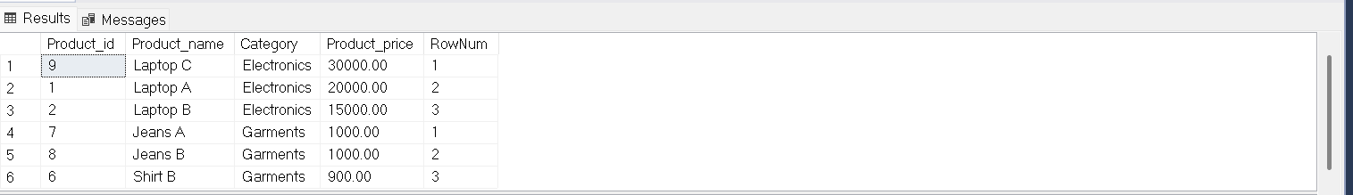

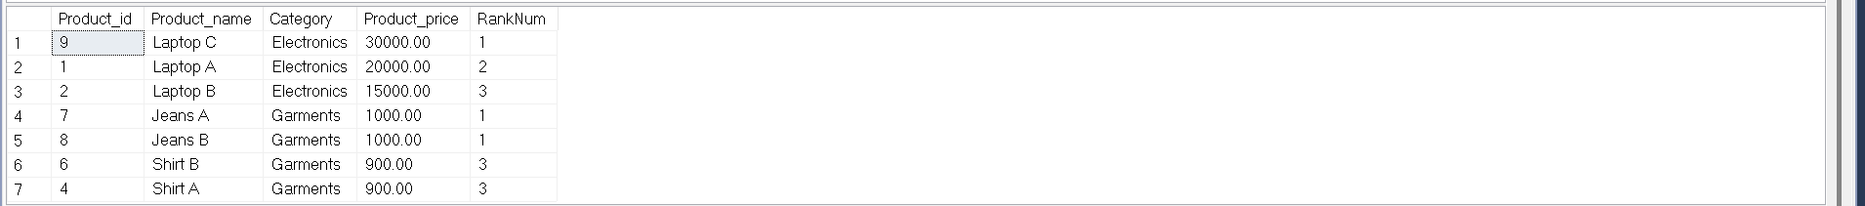

**NOTE:**  The Output Window couldn’t be maximised. So, the order of the output is provided as per the questions.